Invoice To:
DANA ANAND INDIA PRIVATE LIMITED
Survey No.25/2 & 26
Jodalli-580114

Sl.No | Description | Image | HSN  Code | Unit Price (INR) | Qty | Total Price exclusive. Of Tax Rs.
1 | Roots Heavy Duty RB800-Battery operated Ride on Scrubber Drier With SIC Brush  Scrubbing width-800mm  Suction width-1100mm  Theoretical area coverage-4800m²/H  Working Speed ,up to -6 km/hr  Travel Speed-6km/hr  Power Supply-24/240 V/Ah  Total Power-2400 W  No Of Brushes- 2pcs  Fresh water tank-120L  Dirty Water tank-120L  Total Weight empty/ with battery-272/490-240Ah | 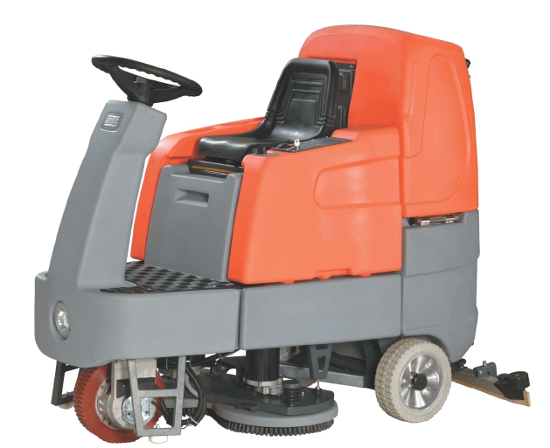 | 8479 | 7,18,081.00 | 1 | 7,18,081.00
2 | Roots Heavy Duty Scrub B6050  Battery operated automatic  Scrubber drier with SIC brush  Scrubbing Width 500mm,  Suction width 850mm,  Theoretical area coverage 2000 m²/h, Working Speed up to 4KM/h,  Battery 12/96 V/Ah,  Air flow rate 28L/Sec,  Fresh water Tank 60L,  Dirty Water Tank 60Ltrs. | 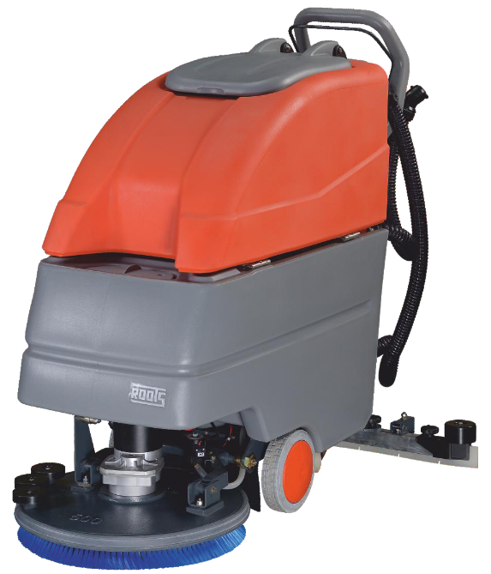 | 8479 | 2,88,546.00 | 1 | 2,88,546.00
3 | ROOTS SCRUB B4545 Battery Operated With Sic Brush  12V/96Ah Automatic Scrubber Drier With Silicon Carbide brush  Tank cap: 45 Ltrs each of Fresh/dirt water, brush width 450mm.Theoriticl area coverage 1800m.sq/hr. | 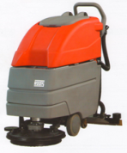 | 8479 | 2,34,298.00 | 1 | 2,34,298.00

Payment Term : 100% Advance Payment along with Purchase Order

TERMS AND CONDITIONS:
- Prices: Price quoted Ex Godown.
- Tax Applicable: GST 18% Extra
- Carrying & Forwarding: 3% Extra
- Freight: to pay basis
- Delivery: Within 2 weeks from the date of receipt of your Purchase Order.
- Warranty: 12 Months from the date of delivery, against all manufacturing defects under normal working conditions (Refer detailed warranty policy for Terms & Conditions).
- Validity: The rates and terms are valid for 30 days from the date of this offer.
- Commissioning & Training: Will be done by our Engineer at your site.

* The Bank Details.
Account Name: KLEAN TECH SYSTEMS
Bank Account Number: 37116560016
Bank Name: State Bank of India
Bank Branch Name: Kusugal Road Branch Hubli.
Keshwapur,
Hubli- 580023 IFSC Code of
Bank Branch: SBIN0040641

Other Details
Our E-mail ID (For sending: kleantechsystems@yahoo.co.in payment advice)
GST No: 29AQEPS9928D1ZB
PAN No: AQEPS9928D

For KLEAN TECH SYSTEMS

Rajesh V Shetti.

* This is a computer generated document and authenticated by KLEAN TECH SYSTEMS. Hence, it can be considered valid even if not signed manually.

